Customer Shopping Behavior Analysis

Project Overview
This project focuses on analysing consumer shopping data for a leading retail company to better understand customer behaviour and changing purchase patterns. The goal is to study differences across customer groups, product categories, and sales channels such as online and offline. By examining factors like discounts, customer reviews, seasonal trends, and payment preferences, the project aims to identify key trends that influence buying decisions and repeat purchases. The insights from this analysis will help the company improve customer engagement, strengthen marketing efforts, and optimize product strategies to support sales growth and long-term customer loyalty.

Dataset Summary
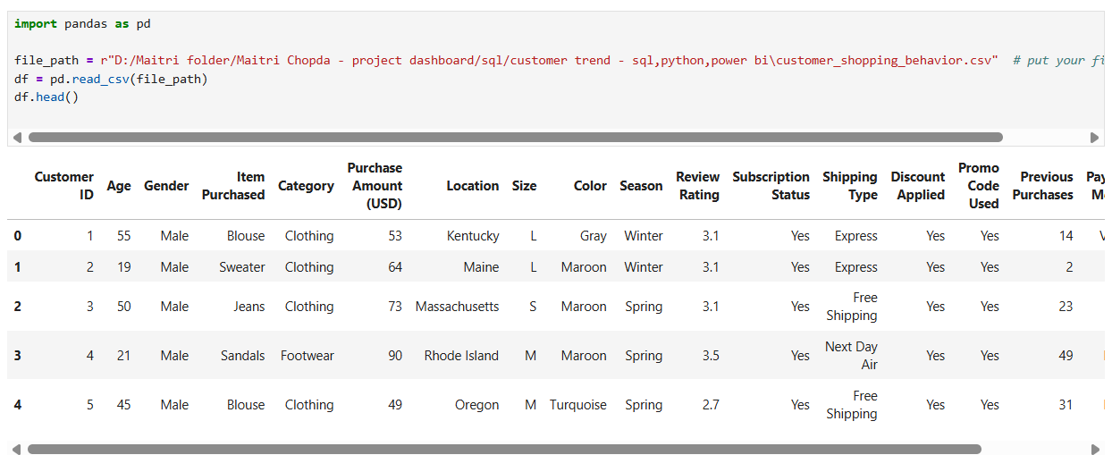

- ROWS : 3900
- COLUMNS : 18
- The dataset contains customer-level shopping data from a retail business.
- Customer details include Customer ID, Age, and Gender.
- Product-related information includes Item Purchased, Category, Size, Color, and Season.
- Transaction details cover Purchase Amount (USD), Location, Shipping Type, and Payment Method.
- Customer behavior features include Review Rating, Subscription Status, Discount Applied, Promo Code Used, and Previous Purchases.
- The dataset captures both online and offline behavior indicators, useful for trend and pattern analysis.
- It supports analysis across demographics, product types, pricing, promotions, and customer loyalty.

Exploratory Data Analysis using Python
Data loading :
The dataset was loaded using the pandas library. The first few records were reviewed to understand column names and sample values. This step helped confirm that the data was loaded correctly and provided a quick overview of customer details, product information, and purchase behavior.
import pandas as pd
df = pd.read_csv("customer_shopping_behavior.csv")
df.head()

Data set shape and structure :
The total number of rows and columns was checked to understand the dataset size. Column data types were reviewed to identify numerical and categorical variables. This step ensured clarity about the dataset structure and helped identify which columns required type conversion or cleaning.
df.shape
df.info()

Missing values :
Missing values were checked to ensure data quality. This step helped identify columns that may need cleaning or handling before analysis. The result confirmed whether the dataset contained null values and helped decide if imputation or removal was required.
df.isnull().sum()
Descriptive Statistics :
Summary statistics were generated for numerical columns such as purchase amount, age, review rating, and previous purchases. This helped understand data spread, average values, and possible outliers. Descriptive statistics provided a clear picture of customer spending behavior and rating patterns.
df.describe()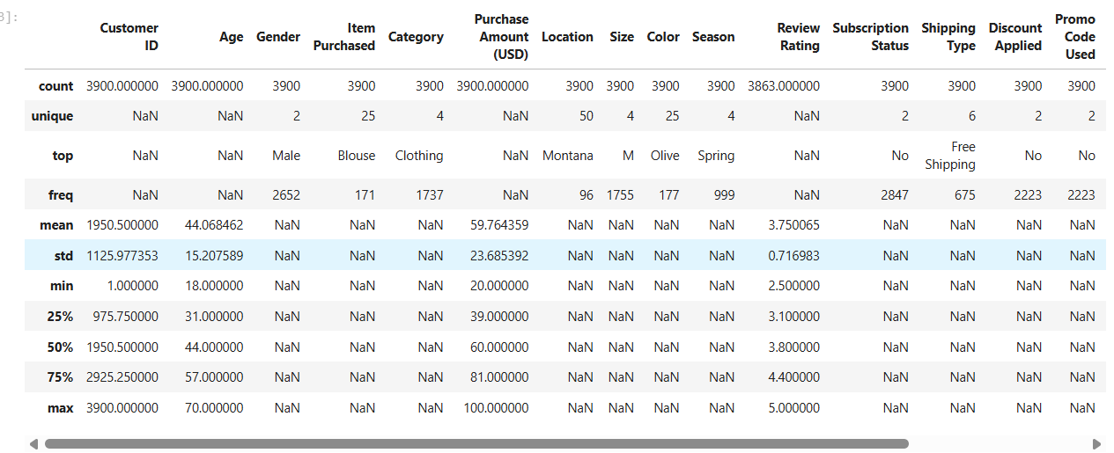

Categorical Data :
Unique values were checked for categorical columns like gender, category, season, shipping type, and subscription status. This helped understand customer choices and product diversity. This analysis supported trend identification across product categories and seasonal demand.
df['Category'].value_counts()
df['Season'].value_counts()

Duplicate Records :
The dataset was checked for duplicate rows to ensure data accuracy. No unnecessary duplication ensured reliable analysis results.
df.duplicated().sum()

Data Analysis using SQL (Business Transactions)
- Revenue by Gender – Compared total revenue generated by male and female customers.
Query :
select gender ,sum(purchase_amount) as revenue
from customer
group by gender;

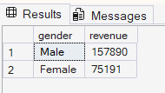

- High-Spending Discount Users – Identified customers who used discounts but still spent above the average purchase amount.

Query :
select customer_id , purchase_amount
from customer
where discount_applied = 'Yes'
and purchase_amount >= (select avg(purchase_amount) from customer);
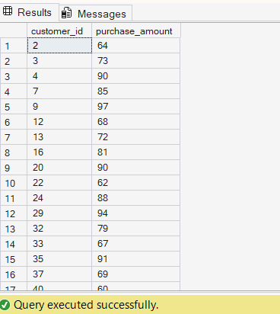

- Top-Rated Products – Identified the top 5 products with the highest average customer review ratings.

Query :
select top 5
item_purchased, AVG(review_rating) as avg_rating
from customer
group by item_purchased
order by avg_rating desc;
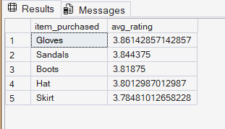

- Shipping Type Spend Comparison – Compared the average purchase amount between Standard and Express shipping options.

Query :
select shipping_type , AVG(purchase_amount) as avg_purchase
from customer
where shipping_type in ('Express', 'Standard')
group by shipping_type;
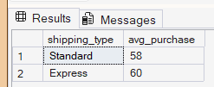

- Subscription Impact on Spending – Compared average spending and total revenue between subscribed and non-subscribed customers.

Query :
select subscription_status, count(customer_id) as total_customer ,
round(avg(purchase_amount),2) as avg_spend,
round(sum(purchase_amount),2) as total_revenue from customer
group by subscription_status
order by total_revenue , avg_spend desc
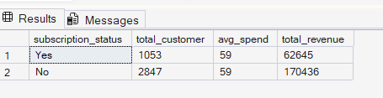

- Discount-Driven Products – Identified the top 5 products with the highest percentage of purchases where discounts were applied.

Query :
select customer_id , purchase_amount
from customer
where discount_applied = 'Yes'
and purchase_amount >= (select avg(purchase_amount) from customer);
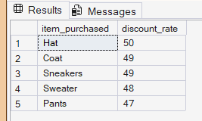

- Customer Segmentation – Segmented customers into New, Returning, and Loyal groups based on their previous purchase count and calculated the size of each segment.

Query :
with customer_type as (
select customer_id , previous_purchases,
case when previous_purchases = 1 then 'New'
when previous_purchases between 2 and 10 then 'Returning'
else 'Loyal'
end as customer_segment
from customer
)

select customer_segment , count(*) as 'NO.of customer'
from customer_type
group by customer_segment

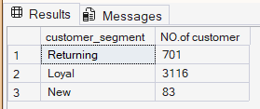

- Category-Level Best Sellers – Identified the top 3 most purchased products within each product category.

Query :
WITH item_counts AS (
SELECT
category,
item_purchased,
COUNT(customer_id) AS total_orders,
ROW_NUMBER() OVER (
PARTITION BY category
ORDER BY COUNT(customer_id) DESC
) AS item_rank
FROM customer
GROUP BY category, item_purchased
)

SELECT
item_rank,
category,
item_purchased,
total_orders
FROM item_counts
WHERE item_rank <= 3;

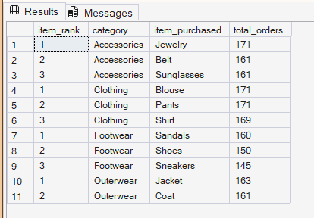

- Repeat Buyer Subscription Analysis – Analyzed whether customers with more than five previous purchases are more likely to be subscribed.

Query :
select subscription_status ,
count(customer_id) as repeat_customer
from customer
where previous_purchases > 5
group by subscription_status;

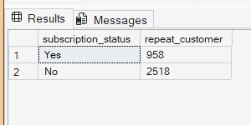

- Revenue by Age Group – Calculated total revenue contribution across different customer age groups.

Query :
select age_group,
sum(purchase_amount) as revenue
from customer
group by age_group
order by age_group desc;
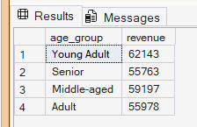

Dashboard in Power BI

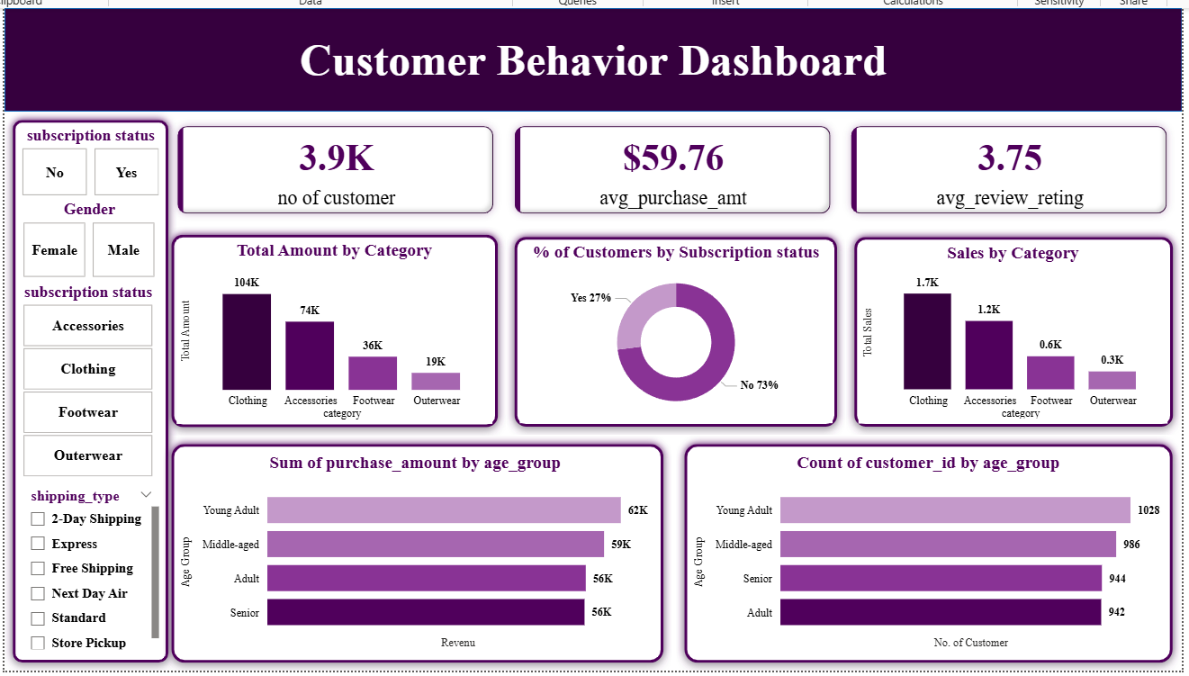

Business Recommendations
• Focus more on female customers – Increase ads, offers, and product designs for female buyers since they generate higher revenue.
• Improve the subscription plan – Add better benefits like exclusive discounts or free shipping because subscribers do not spend more than non-subscribers.
• Convert loyal and repeat customers into subscribers – Target customers with many past purchases using special subscription-only offers.
• Promote best-selling products by category – Highlight top products in Accessories, Clothing, Footwear, and Outerwear to drive more sales.
• Encourage express shipping for higher orders – Promote express shipping with offers, as it leads to higher average purchase value.

